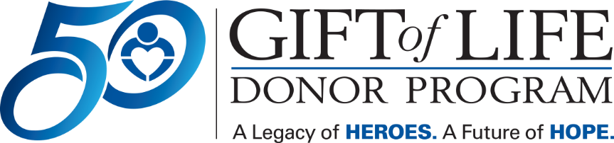

Gift of Life – National Donate Life Month Newsletter Article

Each day, 17 people in the United States die while waiting for an organ transplant. Thousands more await a life-enhancing tissue transplant. Still, many people are not registered to become organ and tissue donors.

[HOSPITAL NAME] is joining forces with Gift of Life Donor Program to increase the number of registered donors.

Ensuring that we have effective donation practices and hospital-wide education in place is an important first step toward an effective and robust donation system. By encouraging hospital staff, their friends and families to register to become organ, tissue, and cornea donors, [HOSPITAL NAME] aims to inspire hope, advocacy and passion among those waiting for a transplant.

“As a health system, we are uniquely positioned to not only tend to the health of our patients, but to inspire our community to be mindful of wellness in all aspects of life,” said [HOSPITAL PRESIDENT/CEO]. “The more people we can inspire to become organ donors, the better we can serve our mission to be leading advocates for the well-being of our entire community.”

[HOSPITAL NAME] encourages its staff to learn the facts and talk with their family members and friends about becoming advocates for organ donation.

The facts are compelling. More than 100,000 people nationally are awaiting an organ transplant. Every eight minutes, another person who needs a transplant is added to the national waitlist. One organ donor can save up to eight lives while a tissue donor can improve the lives of about 100 others. Donation is a possibility only after all efforts to save the patient’s life have been exhausted, tests have been performed to confirm the absence of vital signs, and brain death has been declared.

“Organ donation is the ultimate act of generosity and compassion, a way to give others a second chance at life,” said Richard D. Hasz, President and CEO of Gift of Life. "And it takes less than a minute to register."

To register to become an organ donor or for more information on ways to generate hope, advocacy and passion for others during National Donate Life Month this April, visit Gift of Life’s website at donors1.org.

